**Odoo ERP Project**

**“ Pharmacy Sales Analysis and Business Intelligence Dashboard”**

**Project Overview:**

**This project focuses on analyzing pharmacy sales data using Odoo ERP. It aims to provide insights into sales trends, inventory management, and customer purchasing behavior to optimize business operations. As a final step, an interactive dashboard will be developed to visualize key insights and trends.**

**Prepared by:**

* **Asmaa Hussein Zayed**
* **Dalia Ashraf Nour**
* **Hager Saleh Ahmed**
* **Mahmoud Ashraf Mohamed**
* **Omar Abd El-Moneam Marouf**
* **Sarah Ahmed Mohamed**

**Group Code:**

**ONL2_DAT1_G8**

**Technical Instructor:**

**Jakie Abu Aleam**

**Project Proposal**

|  |  |
| --- | --- |
| **Project Title** | * Pharmacy Data Analysis and Business Intelligence Dashboard |
| **Project Overview** | * This project aims to develop a business intelligence dashboard for pharmacy operations by extracting data from Odoo, storing and processing it in SQL, utilizing Python for ETL (Extract, Transform, Load), and building an interactive Power BI dashboard. The primary objective is to leverage data-driven insights to enhance decision-making, drive sales growth, improve operational efficiency, and support to know customer Behavior. |
| **Objectives** | * Extract and transform pharmacy transaction data from Odoo ERP into a structured SQL database. * Automate data integration using Python-based ETL processes. * Implement data validation and cleaning to ensure accuracy and consistency. * Develop a comprehensive Power BI dashboard for real-time analytics and reporting. * Provide actionable insights for sales trends, inventory management, and customer behavior. |
| **Scope of Work** | * Extract pharmacy transactions and inventory data from Odoo ERP. * Use Python scripts to automate data extraction and transformation. * Store structured data in a SQL database for further analysis. * Implement ETL validation scripts. * Automate the data pipeline for scheduled updates. * Connect Power BI to the SQL database for real-time insights. * Build interactive visualizations. * Conduct end-user training sessions to ensure smooth adoption of the Dashboard, Video tutorials for dashboard usage and documentation reference. * Deliver a final presentation to stakeholders highlighting insights and functionality. |

**Project Plan**

* **Timeline And Gantt Chart**

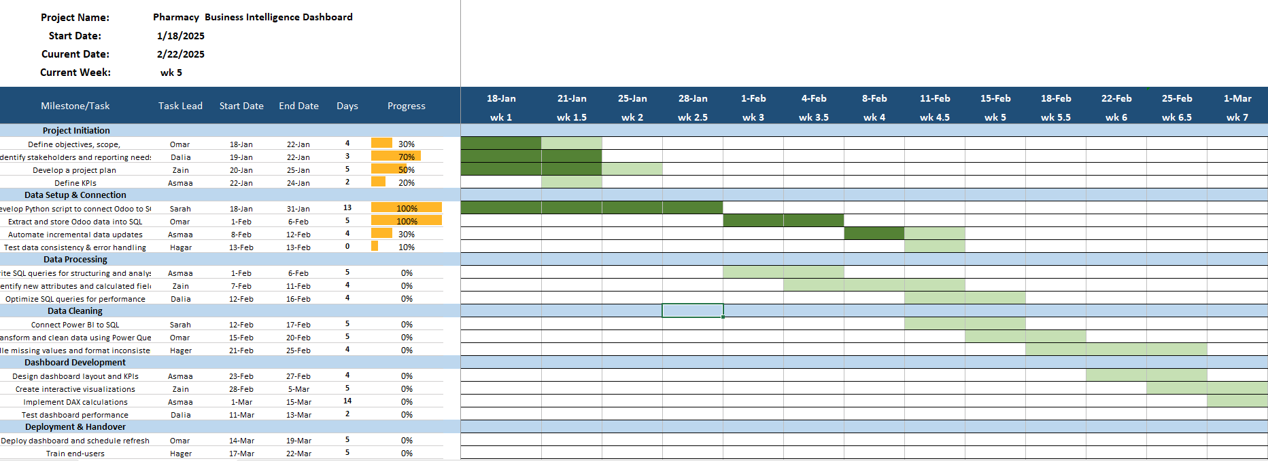

* **Milestones**

|  |  |  |
| --- | --- | --- |
| **Milestone** | **Completion Date** | **Description** |
| **Project Initiation** | 24-Jan | Define objectives, identify stakeholders, develop a project plan, and set KPIs. |
| **Data Setup & Connection** | 13-Feb | Develop Python scripts, extract Odoo data into SQL, automate updates, and ensure data consistency. |
| **Data Processing** | 16-Feb | Write SQL queries for structuring, identify calculated fields, and optimize query performance. |
| **Data Cleaning** | 25-Feb | Connect Power BI to SQL, clean data using Power Query, and handle missing values. |
| **Dashboard Development** | 13-Mar | Design dashboard layout, create interactive visualizations, implement DAX calculations, and test performance. |
| **Deployment & Handover** | 25-Mar | Deploy dashboard, schedule refresh, train end-users, and provide documentation. |
| **Monitoring** | 30-Mar | Ensure Python script runs on schedule, monitor Power BI refresh, and optimize dashboards. |
| **Project Presentation** | 11-Apr | Present the project to stakeholders. |

* **Deliverables**

|  |  |  |
| --- | --- | --- |
| **Deliverable Name** | **Description** | **Related Milestone** |
| Project Scope Document | Document outlining the project objectives and scope. | Project Planning Completed |
| Project Plan | Detailed plan with tasks, roles, and timeline. | Project Planning Completed |
| Python Script for Odoo Connection | Script to connect Odoo to SQL for data extraction. | Data Connection Established |
| SQL Queries for Data Processing | Structured SQL queries and performance-optimized calculations. | Data Processing Completed |
| Power BI Connection | Power BI connected to SQL for real-time reporting. | Data Cleaning Completed |
| Dashboard Design | Dashboard layout and visualizations. | Dashboard Developed |
| Final Dashboard & Visualizations | Fully developed dashboard with DAX calculations. | Dashboard Developed |
| Deployment Report | Deployment report with testing and validation results. | Project Deployment |
| Training & Documentation | User documentation and recorded training materials. | Project Deployment |
| Project Presentation Slides | Slides summarizing the project outcomes and insights. | Project Presentation |

* **Resource**
* **Software Resource**

|  |  |  |
| --- | --- | --- |
| **Software** | **Purpose** | **Usage** |
| **Odoo ERP** | Data Source | Extract transaction & inventory data |
| **SQL Database** | Data Storage | Store and manage structured data |
| **Python (Pandas, SQL Alchemy)** | ETL Development | Automate data extraction and transformation |
| **Power BI** | Dashboard Development | Data visualization and reporting |
| **Excel** | Project Management | Organizing tasks, milestones, and data validation |
| **PowerPoint** | Presentation | Project presentation and training materials |

**Task Assignment and Roles**

|  |  |  |  |
| --- | --- | --- | --- |
| **Task** | **Assigned To** | **Start Date** | **End Date** |
| Define objectives, scope | Omar | 18-Jan | 22-Jan |
| Identify stakeholders and reporting needs | Dalia | 19-Jan | 22-Jan |
| Develop project plan | Zain | 20-Jan | 25-Jan |
| Define KPIs | Asmaa | 22-Jan | 24-Jan |
| Develop Python script for Odoo-SQL | Sarah | 18-Jan | 31-Jan |
| Extract and store Odoo data in SQL | Omar | 1-Feb | 6-Feb |
| Automate incremental data updates | Asmaa | 8-Feb | 12-Feb |
| Test data consistency & error handling | Hagar | 13-Feb | 13-Feb |
| Write SQL queries for analysis | Asmaa | 1-Feb | 6-Feb |
| Identify new attributes & calculated fields | Zain | 7-Feb | 11-Feb |
| Optimize SQL queries | Dalia | 12-Feb | 16-Feb |
| Connect Power BI to SQL | Sarah | 12-Feb | 17-Feb |
| Transform & clean data using Power Query | Omar | 15-Feb | 20-Feb |
| Handle missing values & inconsistencies | Hagar | 21-Feb | 25-Feb |
| Design dashboard layout & KPIs | Asmaa | 23-Feb | 27-Feb |
| Create interactive visualizations | Zain | 28-Feb | 5-Mar |
| Implement DAX calculations | Asmaa | 1-Mar | 15-Mar |
| Test dashboard performance | Dalia | 11-Mar | 13-Mar |
| Deploy dashboard | Omar | 14-Mar | 19-Mar |
| Train end-users | Hagar | 17-Mar | 22-Mar |
| Create PDF documentation | Zain | 20-Mar | 24-Mar |
| Record video tutorial | Hagar | 20-Mar | 25-Mar |
| Ensure Python script runs on schedule | Asmaa | 25-Marr | 28-Mar |
| Monitor Power BI refresh | Dalia | 26-Mar | 29-Mar |
| Optimize queries and dashboards | Hager | 27-Mar | 30-Mar |
| Training all team on Presentation | All Team Members | 1-Apr | 8-Apr |
| present the project | All Team Members | 10-Apr | 11-Apr |

**Risk And Mitigation Plan**

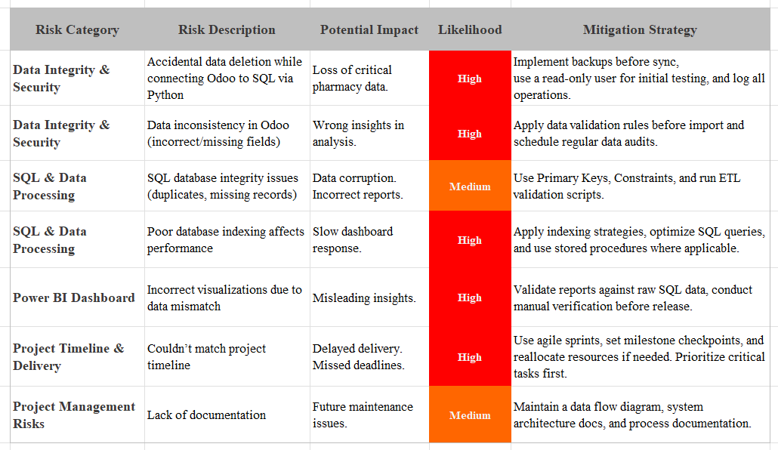

**Key performance Indicators (KPIs)**

|  |  |  |  |
| --- | --- | --- | --- |
| **category** | **KPI** | **Description** | **Target** |
| **Dashboard Accuracy** | Data Consistency Rate | Reports with accurate & validated data | ≥ 98% |
| **User Adoption** | User Engagement Rate | Intended users actively using the dashboard | ≥ 80% |
| **User Adoption** | Training Completion Rate | Users who complete dashboard training | ≥ 90% |
| **Business Insights** | Decision Support Impact | Users who find insights useful for decisions | ≥ 85% |
| **Business Insights** | Sales Trend Analysis | Accuracy of sales forecasts using dashboard | ≥ 95% |
| **Project Timeliness** | Milestone Adherence Rate | % of milestones met on time | ≥ 90% |
| **Project Timeliness** | Task Completion Rate | % of project tasks finished within schedule | ≥ 95% |